MUSIC AT WESLEY
TUESDAY LUNCHTIME CONCERT
Wesley Church Centre, St John St, Chester CH1 1DA
January 5th 2027, 12.45pm
Minsung Park - Piano

3 Sonetti del Petrarca S. 161 (Years of Pilgrimage: ‘Italy’) Franz Liszt (1811 – 86)
Sonetto 47 (Preludio con moto - Sempre mosso con intimo sentiment)
Sonetto 104 (Agitato assai - Adagio)
Sonetto 123 (Lento placido - Sempre lento - Più lento - Tempo iniziale)

Ave Maria: ‘Die Glocken von Rom’ S. 182 Franz Liszt (1811 – 86)

Sonata in B Minor S. 178 Franz Liszt (1811 – 86)
(Introduction) Lento assai – Allegro energico – Grandioso –
Andante sostenuto –
(Fugato): Allegro energico – Presto – Andante sostenuto –
(Coda) Allegro moderato – Lento assai

FUTURE ‘MUSIC AT WESLEY’ CONCERTS

Tuesday Lunchtime Concerts Series, 12.45pm. Retiring collection.
January 12th: Chetham’s School of Music Pianists
January 19th: Pip Clarke (violin), Havilland Willshire (piano)
January 26th: Nina Savicevic (piano)
Saturday Lunchtime Organ Recitals, 12.45pm. Retiring collection.

January 23rd: John Hosking (organ)

Thank you for supporting this recital. The retiring collection (suggested minimum donation £5 per person) covers performer, performing rights and other direct expenses, with the balance in aid of Wesley Church funds. If you are a taxpayer it would be much appreciated if you would donate using a Gift Aid envelope (just add your name, house number & post code).



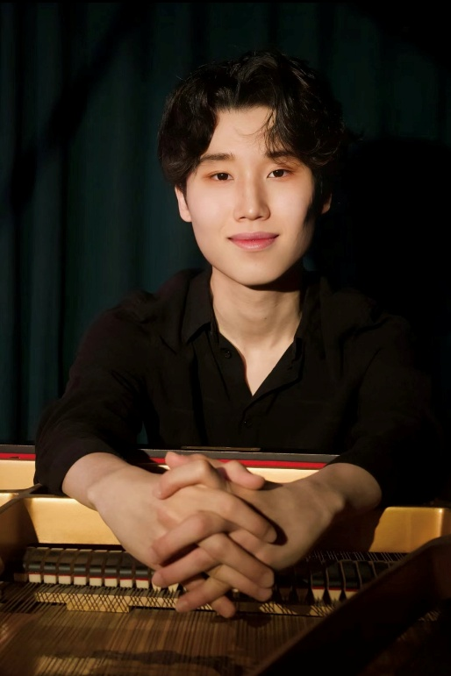

Minsung Park
Born on January 2003 in Busan, South Korea, Minsung Park started the first step of his piano journey at the age of 7. He learnt under Vietnamese pianist Trang Trinh after moving to Vietnam in 2010. After about 6 years of study with her, he moved to Manchester in 2019 and he was accepted at Chetham’s School of Music for 2 years, where he studied piano with Professor Murray McLachlan. Minsung graduated from Chetham’s in 2021 and then studied for a Bachelor of Music degree at the Royal Northern College of Music with Professor Murray McLachlan. In 2025 he successfully graduated from the RNCM with 1st class Honours. Now he is pursuing a Master of Music degree under Professor Graham Scott at the RNCM, thanks to the support from FW Wright Piano Scholarship and SJM Concerts Bursary.

He has a wealth of performance experience with numerous recitals in England. He has also performed internationally in Vietnam, Poland, Italy and France. He has taken part in masterclasses and concert opportunities along with world-class concert pianists and professors, including Sir Stephen Hough, Jean-Efflam Bavouzet, Philippe Cassard, Christopher Elton, Yury Shadrin, Simon Callaghan and Kathryn Stott. In 2024 Minsung made a very successful concerto debut with the St. John’s Festival Orchestra in Chester, performing Rachmaninov’s 2nd Piano Concerto with conductor Adam Davies.

Minsung has made his mark in various UK and international piano competitions. Since 2022 he has been recognized internationally, winning the honorable diploma in the II Krogulski International Piano Competition. A year later he was selected as one of the finalists in the 2023 Watford International Piano Competition. In the same year he won 1st Prize in the 5th Spezzaferri International Music. In 2024 he won the 2nd prize in LOML International Piano Competition (Category B) and in the following year he won the 2025 RNCM Piano Duo Prize with his current duo partner Tsukushi Mitsuda. In May 2025 he won 3rd prize in the RNCM Mark Ray Piano Recital Competition. He was also one of the 6 finalists and laureates in the Liszt Society International Piano Competition 2025, which was held in St Mary’s Perivale.

