*MUSIC AT WESLEY*

TUESDAY LUNCHTIME CONCERT

Wesley Church Centre, St John St, Chester CH1 1DA

September 16th 2025, 12.45pm

MARIE-LOUISE TAYLOR: PIANO

Arabesque no. 1 in E major  Debussy (1862 - 1918)

Préludes:  Debussy (1862 - 1918)

* La fille aux cheveux de lin
* Le vent sur la plaine

Reflets dans l'eau (from ‘Images’, book 1) Debussy (1862 - 1918)

Étude Op. 35 no. 2 'Automne’ Chaminade (1857 - 1944)

Pavane pour une Infante défunte Ravel (1875 - 1937)

Sonatine Ravel (1875 - 1937)

*1. Modéré*

*2.  Mouvement de Menuet*

*3. Animé*

***FUTURE ‘MUSIC AT WESLEY’ LUNCHTIME CONCERTS***

Tuesday Lunchtime Concerts Series, 12.45pm. Retiring collection.

September 23rd: Chetham’s School of Music Instrumentalists

September 30th: Jonathan Richards (guitar)

October 7th: Chester Competitive Festival Winners

Saturday Lunchtime Organ Recitals, 12.45pm. Retiring collection

September 20th:  Daniel Mathieson (Chester Cathedral)

*Thank you for supporting this recital. The retiring collection (suggested minimum donation £4 per person) covers performer, performing rights and other direct expenses, with the balance in aid of Wesley Church funds. If you are a taxpayer it would be much appreciated if you would donate using a Gift Aid envelope (just add your name, house number & post code).*

 

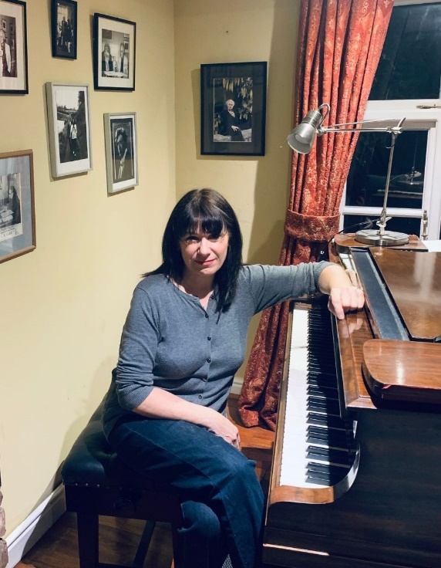

Marie-Louise Taylor comes from a musical family. Her father Harold Taylor was a pianist, conductor, author and music educator who took lessons in Paris with Alfred Cortot, who in turn studied with Émile Descombes, a student of Chopin.

Marie-Louise studied at the Royal Academy of Music, London, after which, she went on a British government Scholarship to the Kodaly Institute, Hungary to study solfege and music education and took piano lessons with Orsolya Sabo and accompaniment with Roland Hadju, teachers at the Liszt Academy, Budapest.

Marie-Louise Taylor has performed for festivals, music clubs and concert halls all over England and abroad, including prestigious venues such as the Wigmore Hall, St John's Smith Square, Royal Holloway College, Reading Arts Centre, The Adrian Boult Hall, Birmingham CBSO centre, the Royal Welsh College of Music, and has appeared on Radio 3.

She has worked as a vocal and instrumental accompanist for the Royal Welsh College of Music and Drama and the Birmingham Conservatoire.

As a successful piano teacher, Marie-Louise specialises in reducing tension in performance using the principles of the Alexander Technique.

She has taught on the keyboard staff at the Universities of Birmingham, Manchester and Chester, the Royal Birmingham Conservatoire and the Royal Northern College of Music Junior Schools and was on the teaching staff at Chetham's School of Music for twenty years.

Marie-Louise examines for school music competitions, the Royal Birmingham Conservatoire, the Manchester University and has been an adjudicator for the Dudley International Piano Competition.

Marie-Louise lives and teaches privately in Romiley, Cheshire and in rural France.