MUSIC AT WESLEY
TUESDAY LUNCHTIME CONCERT
Wesley Church Centre, St John St, Chester CH1 1DA
February 17th 2026, 12.45pm
JUNA STRING QUARTET
Archie Freeman Violin
Nina Doig Violin
Estelle Gonzalez Viola
Elena Edwards Cello

STRING QUARTET IN BЬ MAJOR Op. 76 no. 4 HAYDN (1732 – 1809)
(‘SUNRISE’)
Allegro con spirito
Adagio
Menuetto: Allegro
Finale: Allegro, ma non troppo

STRING QUARTET IN EЬ MAJOR FANNY MENDELSSOHN (1805 – 47)
Adagio ma non troppo
Allegretto
Romanze
Allegro molto vivace

FUTURE ‘MUSIC AT WESLEY’ LUNCHTIME CONCERTS
Tuesday Lunchtime Concerts Series, 12.45pm. Retiring collection.
February 24th: Hwan Hee Kim (piano)
March 3rd: Ben Holland (violin), John Gough (piano)
March 10th: Chetham’s School of Music Brass Ensembles

Saturday Lunchtime Organ Recitals, 12.45pm. Retiring collection
March 21st: Brian Heald (Wesley)

Thank you for supporting this recital. The retiring collection (suggested minimum donation £4 per person) covers performer, performing rights and other direct expenses, with the balance in aid of Wesley Church funds. If you are a taxpayer it would be much appreciated if you would donate using a Gift Aid envelope (just add your name, house number & post code).



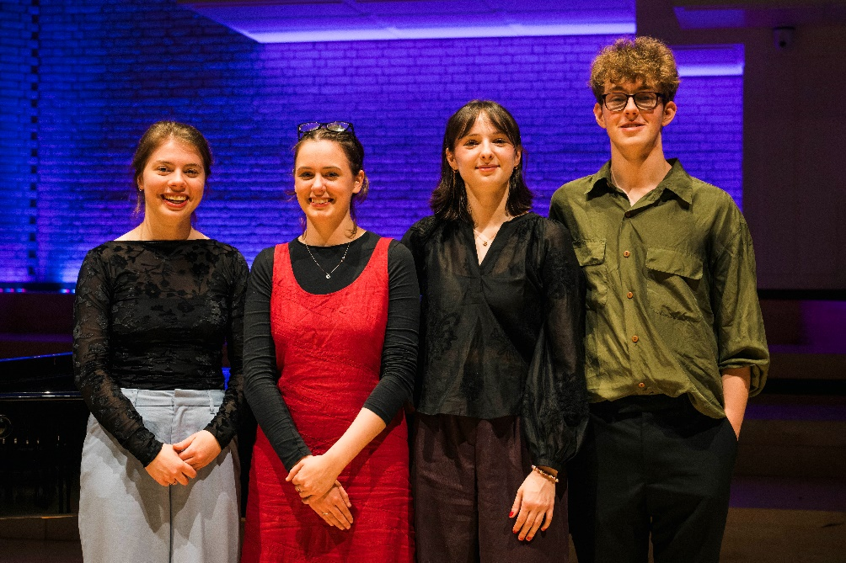

Juna String Quartet
The Juna Quartet are a Manchester based ensemble currently studying at the Royal Northern College of Music. Since forming in 2022, they have enjoyed playing various recitals both within college and externally and won both the Hirsch Prize in 2023 with their performance of Beethoven’s Opus 18 No 1, and the Elias Prize in 2024 with compositions written by their violist and cellist. External concert performances include the Whitworth Art Gallery, House of Books and Friends and the Wye Valley Festival in summer 2025. The quartet is looking forward to prospective concerts in Manchester Cathedral and St Ann’s Church.

Archie Freeman studies violin with Leland Chen at the RNCM. Playing music in small groups is his passion, and prior to joining Juna he played in the Cedar Quartet, who gave regular concerts in the Lancashire area and took part in the Chilingirian Quartet’s acclaimed course in West Dean. He was a member of NYOGB in 2020-21, where he played at the Proms twice. He has given a range of solo recitals and played in masterclasses for Peter Sheppard Skaerved, Fenella Humphreys and Simine Lamsma. In the coming year, he also looks forward to concerts as part of the newly-formed Glen Piano Trio.

Nina Doig studies violin with Leland Chen at the RNCM. She is an alumna of the Music School of Douglas and the Junior Conservatoire of Scotland where she co-lead the Symphony Orchestra. She is currently the co-leader of the National Youth Orchestras of Scotland Symphony. She was a member of NYOGB and the leader of the West of Scotland Schools Symphony Orchestra. Nina has received awards for solo and chamber music playing in the Glasgow Music Festival and has a distinction in a performance diploma.

Estelle Gonzalez is from Lewisham and studies viola at the RNCM under Lucy Nolan, a member of the esteemed Elbana String Trio. She has played in masterclasses with Robin Ireland and Hartmut Rhode. She was the recipient of the Dora Zafransky-Kastner Prize for String-Player and the Vivian Joseph Prize for String Quartet in July 2021 at the Junior Trinity Laban Conservatoire for Music and Dance.

Elena Edwards is a Chetham’s alumna. In 2022 she joined the RNCM with a scholarship made possible thanks to the Jellis Bequest and in 2023 she was fortunate to win the Amy Lindley prize for cello. She has played in masterclasses with Sheku Kanneh-Mason, Cecilia Radic and Richard Bamping and has led and co-led several projects at the RNCM.

