MUSIC AT WESLEY

SATURDAY LUNCHTIME ORGAN RECITAL
Wesley Church Centre, St John St, Chester
September 19th 2026, 12.45pm

DANIEL MATHIESON
(Chester Cathedral)

Choral Song and Fugue S S Wesley (1810 – 76)

Concerto in F H.292 G F Handel (1685 – 1759)
i. Allegro
ii. Andante
iii. Adagio
iv. Allegro
Voluntary in D minor for double organ Henry Purcell (1659 – 95)
Nimrod (‘Enigma Variations’) Edward Elgar (1857 – 1934)

Crown Imperial (Coronation March, 1937) William Walton (1902 – 83)

FUTURE ‘MUSIC AT WESLEY’ LUNCHTIME CONCERTS
Tuesday Lunchtime Concerts Series, 12.45pm. Retiring collection.
September 22nd: Chetham’s School of Music Instrumentalists
September 29th: Jamie Brown (piano)
October 6th: Chester Music Festival Winners

Saturday Lunchtime Organ Recitals, 12.45pm. Retiring collection

October 17th: Christopher Enston (St Asaph Cathedral)
Thank you for supporting this recital. The retiring collection (suggested minimum donation £5 per person) covers performer, performing rights and other direct expenses, with the balance in aid of Wesley Church funds. If you are a taxpayer it would be much appreciated if you would donate using a Gift Aid envelope (just add your name, house number & post code).



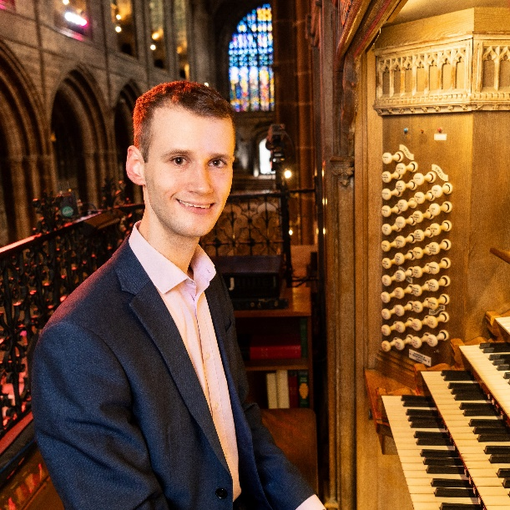

Daniel Mathieson holds the position of Head of Music Outreach and Assistant Organist at Chester Cathedral. In this role he assists in the training of the choristers and playing for daily services alongside the other Cathedral Musicians, and leads the Cathedral’s expanding music outreach programme across the city and beyond.

He began his organ studies at York Minster with David Pipe and went up to Worcester College, Oxford with an organ scholarship, studying the organ with William Whitehead and Dame Gillian Weir and conducting with Jeremy Summerly. After graduating, he took up the organ scholarship at Salisbury Cathedral. Following this, he taught at Radley College while working as Assistant Organist there, before returning to Oxford for postgraduate study.

He subsequently held positions as organist, musical director and tutor across the city and university of Oxford, including as Interim Sub-Organist at Christ Church Cathedral and as Organist and Assistant Director of Music at St. Mary Magdalen. He also worked as Organist and Choir Director at Keble and Worcester Colleges and taught topics for the Music Faculty across the University, as well as the organ at Downe House School.

He is in demand as a recitalist across the UK and overseas: recent recital venues have included St. Paul’s Cathedral, Westminster Cathedral, Münster Cathedral, Magdeburg Cathedral, Halberstadt Cathedral, Halle Cathedral, and for the Three Choirs Festival. He has also worked with the world-renowned Trinity Boys Choir on tours across Europe. He is a prizewinning Fellow of the Royal College of Organists.

Publicity for this recital by www.organrecitals.uk is gratefully acknowledged

